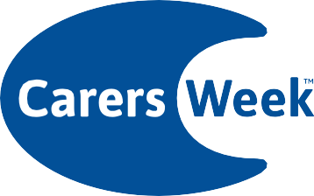
This Carers Week we’re coming together throughout the UK, drawing attention to how important caring is and helping carers to become healthy and connected.
For more information visit
carersweek.org
© 2018. Carers UK is a charity registered in England and Wales (246329) and in Scotland (SC039307) and a company limited by guarantee 864097. Registered office 20 Great Dover Street, London, SE1 4LX

11–17 June 2018
Are you looking after someone?

EDGWORTH MEDICAL CENTRE IS HOLDING A CARERS COFFEE AND CAKE EVENT.

14TH JUNE FORM 11AM-4PM

PLEASE COME AND JOIN US

OUR NURSING STAFF WILL BE OFFERING HEALTH CHECKS, VACINATIONS AND ADVICE .

